NAME______________________________________________________


GCSE to AS Chemistry
Bridging materials

Use your GCSE resources, the internet or a chemistry textbook to help answer these questions in preparation for your AS course in Chemistry.

Good textbooks you could use are:

The course text :
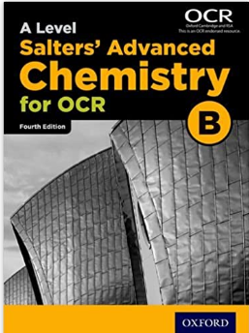

A Level Salters Advanced Chemistry for OCR B (4th ed)
University of York ISBN 978-0198332909

OR

Advanced Chemistry for you Lawrie Ryan (2015 edition)
ISBN 978-1408527368

Useful websites include:

1] Chemguide : www.chemguide.co.uk

2] DocBrown Chemistry : www.docbrown.info/page19/Salters_GCE_chem_A_Level_2015.htm

3] ChemRevise (N. Goaby) : www.chemrevise.org/ocr-revision-guides

Hartismere bridging materials can be found on the school website.
Search for item number : 29071

ESSENTIAL PURCHASE:

CGP Revision Guide New A-Level Chemistry :
OCR B Year 1 & 2 Complete Revision & Practice,
ISBN 978-1782943037

.The main course text will be available to students free of charge in September when starting the course.

You will also be provided with a copy of “Calculations in AS/A Level Chemistry”
By Jim Clark (the person behind the “Chemguide” website)
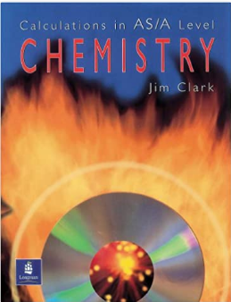

We have copies of other textbooks students may borrow to assist with their independent study.

The CGP Revision guide book is vital – Copies will be available to order through school in September

If you would like more questions feel free to browse the OCR website and look at past papers from the old specification.

Useful information and activities

Greek letters
Greek letters are used often in science. They can be used as symbols for numbers (such as π = 3.14…), as prefixes for units to make them smaller (eg μm = 0.000 000 001 m) or as symbols for particular quantities (such as λ which is used for wavelength). The Greek alphabet is shown below.

Α | α | alpha |  | Ν | ν | nu
Β | β | beta |  | Ξ | ξ | ksi
Γ | γ | gamma |  | Ο | ο | omicron
Δ | δ | delta |  | Π | π | pi
Ε | ε | epsilon |  | Ρ | ρ | rho
Ζ | ζ | zeta |  | Σ | ς or σ | sigma
Η | η | eta |  | Τ | τ | tau
Θ | θ | theta |  | Υ | υ | upsilon
Ι | ι | iota |  | Φ | φ | phi
Κ | κ | kappa |  | Χ | χ | chi
Λ | λ | lambda |  | Ψ | ψ | psi
Μ | μ | mu |  | Ω | ω | omega

Activity 1
A lot of English words are derived from Greek ones, but it’s difficult to see as the alphabet is so different.
Many of the Greek letters are pronounced like the start of their name. For example, omega is pronounced “o”, sigma is pronounced “s” and lambda is pronounced “l”.
See if you can work out what the following Greek words mean by comparing the phonetic spelling with similar English words.

Πυθαγόρας |  | Name of a mathematician
Ωκεανος |  | Atlantic, Pacific or Arctic…
μόνος |  | Single
Τηλε |  | Far or distant
Τρωγλοδύτης |  | Cave dweller

SI units
Every measurement must have a size (eg 2.7) and a unit (eg metres or ºC). Sometimes there are different units available for the same type of measurement, for example ounces, pounds, kilograms and tonnes are all used as units for mass.
To reduce confusion and to help with conversion between different units, there is a standard system of units called the SI units which are used for most scientific purposes.
These units have all been defined by experiment so that the size of, say, a metre in the UK is the same as a metre in China.
The seven SI base units are:
Physical quantity | Usual quantity symbol | Unit | Abbreviation
mass | m | kilogram | kg
length | l or x | metre | m
time | t | second | s
electric current | I | ampere | A
temperature | T | kelvin | K
amount of substance | N | mole | mol
luminous intensity | (not used at A-level) | candela | cd

All other units can be derived from the SI base units.
For example, area is measured in square metres (written as m²) and speed is measured in metres per second (written as ms^{–1}).
It is not always appropriate to use a full unit. For example, measuring the width of a hair or the distance from Manchester to London in metres would cause the numbers to be difficult to work with.
Prefixes are used to multiply each of the units. You will be familiar with centi (meaning 1/100), kilo (1000) and milli (1/1000) from centimetres, kilometres and millimetres.
There is a wide range of prefixes. The majority of quantities in scientific contexts will be quoted using the prefixes that are multiples of 1000. For example, a distance of 33 000 m would be quoted as 33 km.

The most common prefixes you will encounter are:

Prefix | Symbol | Multiplication factor
Tera | T | 10¹² | 1 000 000 000 000
Giga | G | 10⁹ | 1 000 000 000
Mega | M | 10⁶ | 1 000 000
kilo | k | 10³ | 1000
deci | d | 10⁻¹ | 0.1 | 1/10
centi | c | 10⁻² | 0.01 | 1/100
milli | m | 10⁻³ | 0.001 | 1/1000
micro | μ | 10⁻⁶ | 0.000 001 | 1/1 000 000
nano | n | 10⁻⁹ | 0.000 000 001 | 1/1 000 000 000
pico | p | 10⁻¹² | 0.000 000 000 001 | 1/1 000 000 000 000
femto | f | 10^{–15} | 0.000 000 000 000 001 | 1/1 000 000 000 000 000

Activity 2
Which SI unit and prefix would you use for the following quantities?
- The mass of water in a test tube.

- The time taken for a solution to change colour.

- The radius of a gold atom.

- The volume of water in a burette.

- The amount of substance in a beaker of sugar.

- The temperature of the blue flame from a Bunsen burner.

Sometimes, there are units that are used that are not combinations of SI units and prefixes.
These are often multiples of units that are helpful to use. For example, one litre is 0.001 m³.

Activity 3
Rewrite the following in SI units.
- 5 minutes

- 2 days

- 5.5 tonnes

Activity 4
Rewrite the following quantities.
- 0.00122 metres in millimetres

- 104 micrograms in grams

- 1.1202 kilometres in metres

- 70 decilitres in millilitres

- 70 decilitres in litres

- 10 cm³ in litres

Important vocabulary for practical work
Activity 5 Join the boxes to link the word to its definition.

Accurate |  | A statement suggesting what may happen in the future.

Data |  | An experiment that gives the same results when a different person carries it out, or a different technique or set of equipment is used.

Precise |  | A measurement that is close to the true value.

Prediction |  | An experiment that gives the same results when the same experimenter uses the same method and equipment.

Range |  | Physical, chemical or biological quantities or characteristics.

Repeatable |  | A variable that is kept constant during an experiment.

Reproducible |  | A variable that is measured as the outcome of an experiment.

Resolution |  | This is the smallest change in the quantity being measured (input) of a measuring instrument that gives a perceptible change in the reading.

Uncertainty |  | The interval within the true value can be expected to lie.

Variable |  | The spread of data, showing the maximum and minimum values of the data.

Control variable |  | Measurements where repeated measurements show very little spread.

Dependent  variable |  | Information, in any form, that has been collected.

Precise language
It is essential at AS and A-level to use precise language when you write reports and when you answer examination questions. You must always demonstrate that you understand a topic by using the correct and appropriate terms.
For example, you should take care when discussing bonding to refer to the correct particles and interactions between them.
Also, when discussing the interaction between particles in an ionic solid, you would demonstrate a lack of understanding if you referred to the particles as atoms or molecules instead of ions or the interaction between these ions as intermolecular forces rather than electrostatic forces. In this case, use of the incorrect terms would result in the loss of all the marks available for that part of a question.
Take care also to use the word ‘chloride’ and not ‘chlorine’ when referring to the ions in a compound such as sodium chloride. The word ‘chlorine’ should only be used for atoms or molecules of the element.

The periodic table
The periodic table of elements is shown on the back page of this booklet. The A-level course will build on what you’ve learned in your GCSE studies.

Activity 6
On the periodic table on the following page:
- Draw a line showing the metals and non-metals.
- Colour the transition metals blue.
- Colour the halogens yellow.
- Colour the alkali metals red.
- Colour the noble gases green.
- Draw a blue arrow showing the direction of periods.
- Draw a red arrow showing the direction of groups.
- Draw a blue ring around the symbols for all gases.
- Draw a red ring around the symbols for all liquids.

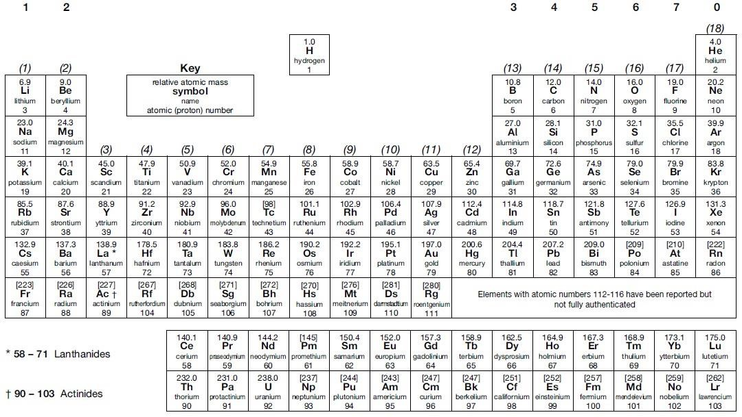

Activity 7
Use the periodic table to find the following:
- The atomic number of: osmium, sodium, lead, chlorine.

- The relative atomic mass of: helium, barium, europium, oxygen.

- The number of protons in: mercury, iodine, calcium.

- The symbol for: gold, lead, copper, iron.

- The name of: Sr, Na, Ag, Hg.

- THInK can be written using a combination of the symbols for Thorium, Indium and
Potassium (ThInK). Which combinations of element symbols could be used to make the following words?

AMERICA, FUN, PIRATE, LIFESPAN, FRACTION, EROSION, DYNAMO

Activity 8: research activity
Research either:
The history of the periodic table
OR
The history of models of atomic structure.

Present your findings as a simple timeline. You should include the work of at least four people. For each, explain what evidence or experiments they used and how this changed the understanding of chemistry.

Relative atomic mass (A_{r})
If there are several isotopes of an element, the relative atomic mass will take into account the proportion of atoms in a sample of each isotope.

For example, chlorine gas is made up of 75% of chlorine-35 ³⁵₁₇C𝑙 and 25% of chlorine-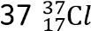.

The relative atomic mass of chlorine is therefore the mean atomic mass of the atoms in a sample, and is calculated by:

Activity 9
- What is the relative atomic mass of Bromine, if the two isotopes, ⁷⁹Br and ⁸¹Br, exist in equal amounts?

- Neon has three isotopes. ²⁰Ne accounts for 90.9%, ²¹Ne accounts for 0.3% and the last 8.8% of a sample is ²²Ne. What is the relative atomic mass of neon?

- Magnesium has the following isotope abundances: ²⁴Mg: 79.0%; ²⁵Mg: 10.0% and 26 Mg:
11.0%. What is the relative atomic mass of magnesium?

Harder:
- Boron has two isotopes, ¹⁰B and ¹¹B. The relative atomic mass of boron is 10.8. What are the percentage abundances of the two isotopes?

- Copper’s isotopes are ⁶³Cu and ⁶⁵Cu. If the relative atomic mass of copper is
63.5, what are the relative abundances of these isotopes?

Relative formula mass (M_{r})
Carbon dioxide, CO₂ has 1 carbon atom (A_{r} = 12.0) and two oxygen atoms (A_{r} = 16.0). The relative formula mass is therefore
M_{r} = (12.0 × 1) + (16.0 × 2) = 44.0
Magnesium hydroxide Mg(OH)₂ has one magnesium ion (A_{r} = 24.3) and two hydroxide ions, each with one oxygen (A_{r} = 16.0) and one hydrogen (A_{r} = 1.0).

The relative formula mass is therefore:

(24.3 × 1) + (2 × (16.0 + 1.0)) = 58.3

Activity 10
Calculate the relative formula mass of the following compounds:
- Magnesium oxide MgO

- Sodium hydroxide NaOH

- Copper sulfate CuSO₄

- Ammonium chloride NH₄Cl

- Ammonium sulfate (NH₄)₂SO₄

Common ions

Positive ions (cations) |  | Negative ions (anions)
Name | Symbol | Name | Symbol
Hydrogen | H⁺ | Hydroxide | OH⁻
Sodium | Na⁺ | Chloride | Cl⁻
Lithium | Li⁺ | Bromide | Br⁻
Silver | Ag⁺ | Oxide | O²⁻
Magnesium | Mg²⁺ | Hydrogencarbonate | HCO₃⁻
Calcium | Ca²⁺ | Nitrate | NO₃⁻
Zinc | Zn²⁺ | Sulfate | SO₄²⁻
Aluminium | Al³⁺ | Carbonate | CO₃²⁻
Ammonium | NH₄⁺ | Phosphate | PO₄³⁻

Some elements have more than one charge. For example, iron can form ions with a charge of +2 or +3. Compounds containing these are named Iron(II) and Iron(III) respectively.
Other common elements with more than one charge include:
Chromium(II) and chromium(III)
Copper(I) and copper(II)
Lead(II) and lead(IV)

Activity 11
On the periodic table on the following page, colour elements that form one atom ions (eg Na⁺ or O^{2–}) according to the following key:

 | Charge | Colour
 | +1 | red
 | +2 | yellow
 | +3 | green
 | -1 | blue
 | -2 | brown

Ionic compounds must have an overall neutral charge. The ratio of cations to anions must mean that there is as many positives as negatives.
For example:

NaCl |  |  | MgO |  |  | MgCl₂
Na⁺ | Cl– |  | Mg²⁺ | O2– |  | Mg²⁺ | Cl–
 |  |  |  |  |  |  | Cl–
+1 | -1 |  | +2 | –2 |  | +2 | –2

Activity 12
Work out what the formulas for the following ionic compounds should be:

- Magnesium bromide

- Barium oxide

- Zinc chloride

- Ammonium chloride

- Ammonium carbonate

- Aluminium bromide

- Iron(II) sulfate

- Iron(III) sulfate

Diatomic molecules
A number of atoms exist in pairs as diatomic (two atom) molecules.
The common ones that you should remember are:
Hydrogen H₂, Oxygen O₂, Fluorine F₂, Chlorine Cl₂, Bromine Br_{2,} Nitrogen N₂ and Iodine I₂

Common compounds
There are several common compounds from your GCSE studies that have names that do not help to work out their formulas. For example, water is H₂O.

Activity 13: Research activity
What are the formulas of the following compounds?
- Methane

- Ammonia

- Hydrochloric acid

- Sulfuric acid

- Sodium hydroxide

- Potassium manganate(VII)

- Hydrogen peroxide

Balancing equations
Chemical reactions never create or destroy atoms. They are only rearranged or joined in different ways.
When hydrogen and oxygen react to make water: hydrogen + oxygen ➔ water
H₂ + O₂ ➔ H₂O
There are two hydrogen atoms on both sides of this equation, but two oxygen atoms on the left and only one on the right. This is not balanced.
This can be balanced by writing:
2H₂ + O₂ ➔ 2H₂O
The reactants and products in this reaction are known and you can’t change them. The compounds can’t be changed and neither can the subscripts because that would change the compounds. So, to balance the equation, a number must be added in front of the compound or element in the equation. This is a coefficient. Coefficients show how many atoms or molecules there are.

Activity 14
Write balanced symbol equations for the following reactions. You’ll need to use the information on the previous pages to work out the formulas of the compounds. Remember some of the elements may be diatomic molecules.
- Aluminium + oxygen ➔ aluminium oxide

- Methane + oxygen ➔ carbon dioxide + water

- Aluminium + bromine ➔ aluminium bromide

- Calcium carbonate + hydrochloric acid ➔ calcium chloride + water + carbon dioxide

- Aluminium sulfate + calcium hydroxide ➔ aluminium hydroxide + calcium sulfate

Harder:
- Silver nitrate + potassium phosphate ➔ silver phosphate + potassium nitrate

More challenging:

Potassium manganate(VII) + hydrochloric acid ➔ potassium chloride + manganese(II) chloride
+ water + chlorine

Moles
A mole is the amount of a substance that contains 6.02 × 10²³ particles.

The mass of 1 mole of any substance is the relative formula mass (M_{r}) in grams.

Examples:
One mole of carbon contains 6.02 × 10²³ particles and has a mass of 12.0 g
Two moles of copper contains 12.04 × 10²³ particles, and has a mass of 127 g 1 mole of water contains
6.02 × 10²³ particles and has a mass of 18 g

The amount in moles of a substance can be found by using the formula:

Activity 15
Fill in the table.
Substance | Mass of substance | Amount/moles | Number of particles
Helium |  |  | 18.12 × 10²³
Chlorine | 14.2
Methane |  | 4
Sulfuric acid | 4.905

Empirical formula
If you measure the mass of each reactant used in a reaction, you can work out the ratio of atoms of each reactant in the product. This is known as the empirical formula. This may give you the actual chemical formula, as the actual formula may be a multiple of this. For example, hydrogen peroxide is H₂O₂ but would have the empirical formula HO.

Use the following to find an empirical formula:

- Write down reacting masses
- Find the amount in moles of each element
- Find the ratio of moles of each element

Example:

A compound contains 2.232 g of ion, 1.284 g of sulfur and 1.920 g of oxygen. What is the empirical formula?

Element | Iron | Sulfur | Oxygen
mass/relative atomic mass | 2.232/55.8 | 1.284/32.1 | 1.920/16.0
Amount in moles | 0.040 | 0.040 | 0.120
Divide by smallest value | 0.040/0.040 | 0.040/0.040 | 0.120/0.040
Ratio | 1 | 1 | 3

So the empirical formula is FeSO_{3.}

If the question gives the percentage of each element instead of the mass, replace mass with the percentage of an element present and follow the same process.

Activity 16
Work out the following empirical formulas:
- The smell of a pineapple is caused by ethyl butanoate. A sample is known to contain only 0.180 g of carbon, 0.030 g of hydrogen and 0.080 g of oxygen. What is the empirical formula of ethyl butanoate?

- Find the empirical formula of a compound containing 0.0578 g of titanium, 0.288 g of carbon,
0.012 g of hydrogen and 0.384 g of oxygen.

- 300 g of a substance are analysed and found to contain only carbon, hydrogen and oxygen. The sample contains 145.9 g of carbon and 24.32 g of hydrogen. What is the empirical formula of the compound?

- Another 300 g sample is known to contain only carbon, hydrogen and oxygen. The percentage of carbon is found to be exactly the same as the percentage of oxygen. The percentage of hydrogen is known to be 5.99%. What is the empirical formula of the compound?

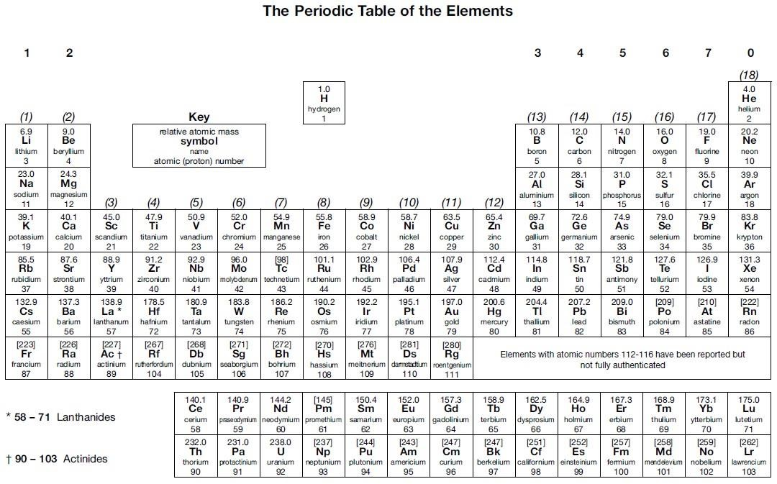
Activity 17 : Equations that you’ve done !
Feel free to research/remind yourself. Try these questions to refresh your equations

Group 7

Q1] This is a halogen displacement reaction :

Cl₂ _{(aq)} + 2LiBr _{(aq)} ➔ Br_{2 (aq)} + 2LiCl _{(aq)}

a) Why is lithium bromide used “in solution” for this reaction, as it would normally be a solid at room temperature and pressure.

_____________________________________________________________________________

_____________________________________________________________________________

b) What would you SEE happening at this reaction takes place ?

_____________________________________________________________________________

_____________________________________________________________________________

c) Suggest why chlorine is used in solution for this reaction, as chlorine is a gas ?

d) What is the role (“job”) of lithium ions in this reaction ?

e) Write an ionic equation for this reaction by removing the “spectator ions”.

f) Which is the more powerful reducing agent in this reaction Cl atoms or Br ⁻ ions ?
How do you know ? (a reducing agent reduces the thing that it is reacting with by giving it electrons !)

_____________________________________________________________________________

_____________________________________________________________________________

g) Describe what you would observe if you added silver nitrate solution to the products of this reaction ?

_____________________________________________________________________________
Metal + Acid

[General equation] Metal + acid ➔ metal salt + hydrogen

The salt depends on the acid used.
HCl forms chloride salts
H₂SO₄ forms sulphate salts
HNO₃ forms nitrate salts

Q2] Select the correct formulae of the following metal salts formed in reactions with acids, by looking at the charges and getting the total + charge to equal the total - charge, from the four choices for each question

a] Potassium sulphate

KSO₄ | K₂SO₄ | K(SO₄)₂ | K₃SO₄

b] Zinc Nitrate

ZnNO₃ | Zn₂NO₃ | Zn(NO₃)₂ | Zn(NO₃)₃

c] Iron III chloride

FeCl | Fe₃Cl | FeCl₂ | FeCl₃

Q3] Complete these metal – acid equations :
Li forms 1+ ions
Mg forms 2+ ions
Al forms 3+ ions

a)
____ Li _{(s)} + ____ HCl _{(aq)} ➔ ____ LiCl _{(aq)} + ____H_{2(g)}

b)
____ Li _{(s)} + ____ HNO₃ _{(aq)} ➔ ____ ________ _{(aq)} + ____H_{2(g)}

c)
____ Li _{(s)} + ____ H₂SO₄ _{(aq)} ➔ ____ ________ _{(aq)} + ___ ______{(g)}

d)
____ Mg _{(s)} + ____ HCl _{(aq)} ➔ ____ MgCl₂ _{(aq)} + ____H_{2(g)}

e)
____ Mg _{(s)} + ____ HNO₃ _{(aq)} ➔ ____ ________ _{(aq)} + ____H_{2(g)}

f)
____ Mg _{(s)} + ____ H₂SO₄ _{(aq)} ➔ ____ ________ _{(aq)} + ___ ______{(g)}

g)
____ Al _{(s)} + ____ HCl _{(aq)} ➔ ____ AlCl₃ _{(aq)} + ____H_{2(g)}

h)
____ Al _{(s)} + ____ HNO₃ _{(aq)} ➔ ____ ________ _{(aq)} + ____H_{2(g)}

i)
____ Al _{(s)} + ____ H₂SO₄ _{(aq)} ➔ ____ ________ _{(aq)} + ___ ______{(g)}

Q4] You can also represent these reactions as ionic equations – which show more detail on what actually happened.

eg/ [full equation] 2Rb _{(s)} + 2HCl _{(aq)} ➔ 2RbCl _{(aq)} + H_{2(g)}

decisions:
- the acid part of the HCl (the thing that makes HCl an acid) are the H⁺ ions.
- here Cl is Cl⁻ ions on the left and Cl⁻ ions on the right. In other words, no change ! Spectator ions … ….remove them.
- have to leave the H₂ in at the end to show what happened to the H+ ions.

Answer:
[ionic equation] 2Rb + 2H⁺ ➔ 2Rb⁺ + H₂
write ionic equations for the following metal – acid reactions:

a) [Full] 2Cs + 2HNO₃ ➔ 2CsNO₃ + H₂

b) [Full] Cu + 2HNO₃ ➔ Cu(NO₃)₂ + H₂

c) [Full] 2Fe + 6HNO₃ ➔ 2Fe(NO₃)₃ + 3H₂

d) [Full] 2Cs + H₂SO₄ ➔ Cs₂SO₄ + H₂

e) [Full] 2Cs + 2HCl ➔ 2CsCl + H₂

Acid reactions
- anything that reacts with an acid (and neutralises it) is known as a “base”.

- bases include : metal elements (eg/ Cu), metal oxide compounds (eg/ CuO), metal hydroxide
compounds (eg/ Cu(OH)₂ ) and metal carbonate compounds (eg/ CuCO₃).

- some metal hydroxides are soluble in water. These are known as “alkalis”.
(eg/ LiOH, NaOH, KOH)

- they’re all neutralisation reactions.

- in each reaction, the acid does the same thing !
It gives away H⁺ ions that turn into either H₂ gas (reaction with metal only) or H₂O.

- once again, the type of acid determines the type of salt formed :
HCl forms chloride salts
H₂SO₄ forms sulphate salts
HNO₃ forms nitrate salts

Here are the general equations for these reactions:

Metal oxide + acid ➔ metal salt + water
(eg/ Na₂O + 2HCl ➔ 2NaCl + H₂O………… H₂O because 2xH from acid and O from base)

Metal hydroxide + acid ➔ metal salt + water
(eg/ NaOH + HCl ➔ NaCl + H₂O ……… H₂O because H from acid and OH from base)

Metal carbonate + acid ➔ metal salt + water + carbon dioxide
(eg/ Na₂CO₃ + 2HCl ➔ 2NaCl + H₂O + CO₂ )

Metal oxide + acid

Q5] Complete these equations (some just require balancing):

a)
____ Li₂O _{(s)} + ____ HCl _{(aq)} ➔ ____ LiCl _{(aq)} + ____H₂O_{(l)}

b)
____ Li₂O + ____ HNO₃ _{(aq)} ➔ ____ ________ _{(aq)} + ____ H₂O_{(l)}

c)
____ Li₂O _{(s)} + ____ H₂SO₄ _{(aq)} ➔ ____ _______ _{(aq)} + ___ ______{(l)}

d)
____ MgO _{(s)} + ____ HCl _{(aq)} ➔ ____ MgCl₂ _{(aq)} + ____ H₂O_{(l)}

e)
____ MgO _{(s)} + ____ HNO₃ _{(aq)} ➔ ____ _______ _{(aq)} + ___ H₂O_{(l)}

f)
____ MgO _{(s)} + ____ H₂SO₄ _{(aq)} ➔ ____ ______ _{(aq)} + ___ ______{(l)}

g)
____ Al₂O₃ _{(s)} + ____ HCl _{(aq)} ➔ ____ AlCl₃ _{(aq)} + ____ H₂O_{(l)}

h)
____ Al₂O₃ _{(s)} + ____ HNO₃ _{(aq)} ➔ ____ ________ _{(aq)} + ____ H₂O_{(l)}

i)
____ Al₂O₃ _{(s)} + ___ H₂SO₄ _{(aq)} ➔ ____ _______ _{(aq)} + ___ ______{(l)}

Q6] Write ionic equations for Q5a, 5d and 5g in the space below.

Metal hydroxide + acid reactions

Q7] Complete these equations (some just require balancing):

a)
____ NaOH _{(aq)} + ____ HCl _{(aq)} ➔ ____ NaCl _{(aq)} + ____H₂O_{(l)}

b)
____ NaOH + ____ HNO₃ ➔ ____ ________ + ____ H₂O

c)
____ NaOH + ____ H₂SO₄ ➔ ____ ________ + ___ _____

Note : Calcium hydroxide is only sparingly soluble in water. The solution is known as limewater.

d)

____ Ca(OH)₂ _{(aq)} + ____ HCl _{(aq)} ➔ ____ ________{(aq)} + ____ H₂O_{(l)}

e)

___ Ca(OH)₂ _{(aq)} + ___ H₂SO₄ _{(aq)} ➔ ____ ______ _{(aq)} + ___ ______{(l)}

Q8] Write ionic equations for Q7a and 7b in the space below

Metal carbonate + acid reactions

Q9] Complete these equations (some just require balancing):

a)
___ Li₂CO₃ _{(s)} + ___ HCl _{(aq)} ➔ ___ LiCl _{(aq)} + ___H₂O_{(l)} + ___CO₂ _{(g)}

b)
___ Li₂CO₃ + ___ HNO₃ ➔ ___ ______ + ___ H₂O + ___CO₂

c)
___ Li₂CO₃ + ___ H₂SO₄ ➔ ___ _______ + ________ + ______

d)
____ CaCO₃ + ___ HCl ➔ ___ CaCl₂ + ____H₂O + ___CO₂

e)
___ CaCO₃ + ___ H₂SO₄ ➔ ___ ________ + ____H₂O + ___CO₂

f)
____ Al₂(CO₃)₃ + ____ HCl ➔ __________ + _________+ ______

Q10] Write ionic equations for Q9a and 9d below
Remember, the acid donates its H⁺, the negative ion part (the non-metal bit) of the base accepts the acids H^{+.}

