 Required practical 1: Looking at cells
Aiming for 6
Specification references:
- Required practical activity 1: Use a light microscope to observe, draw and label a selection of plant and animal cells. A magnification scale must be included.
- B1.1.2 Animal and plant cells
- MS 1b, 1d, 3a
- WS 1.2
- AT 1 Use appropriate apparatus to record length and area.
- AT 7 Use a microscope to make observations of biological specimens and produce labelled scientific drawings.
Aims
In this practical you will use a light microscope to observe plant and animal cells under the microscope. You will make labelled drawings of the cells you observe and calculate magnification.
Learning outcomes
After completing this required practical, you should be able to:
- use a light microscope to identify the main sub-cellular structures in a cell
- calculate the total magnification of the microscope
- take a measurement of the length of a cell, as viewed through the microscope
- calculate the length of a cell from a microscope observation
- prepare a microscope slide.
Safety
- Take care when handling glass slides as they are very fragile.
- Avoid getting iodine solution on your skin.
- Wear eye protection.
- Take care not to break the slide by moving the objective lens too far downwards.
Equipment
- light microscope with low and high power objective lenses
- microscope slide and cover slip
- selection of samples: onion, Elodea, filamentous algae
- dilute iodine solution
- dropper pipette
- scalpel, scissors, forceps
- mounted needle
- blotting paper or filter paper
- range of prepared animal cells including cheek cells and red blood cells
- range of prepared plant cells including onion epidermal cells and leaf palisade cells
Setting the scene
Refer to Chapter 1, Cell structure and transport in the student book for information on using a microscope to look at animal and plant cells.
Method

Preparing your slide
- Collect a sample of the cell you want to observe.
- Remove the inner skin of a layer of onion using forceps, or a thin layer or Elodea or filamentous algae using the scalpel.
- Place the thin slice onto a clean glass slide. Use your forceps to keep the onion skin flat on the glass slide.
- Using a pipette, add one or two drops of dilute iodine solution on top of the onion skin or slice of algae or plant.

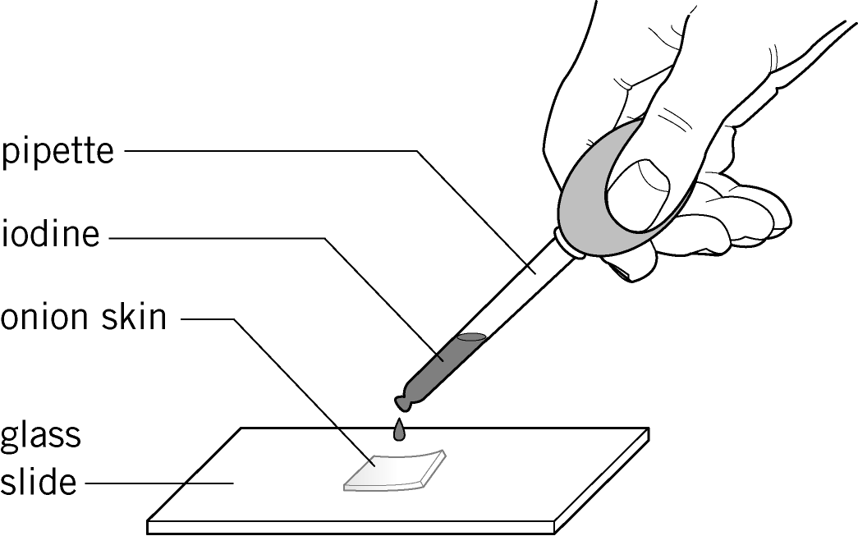

- Hold the coverslip by its side and lay one edge of the cover slip onto the microscope slide near the specimen.
- Lower the cover slip slowly so that the liquid spreads out.

Setting up your microscope
Before you can look at the cells on the slide, you will need to set up your microscope.
Most microscopes have a built-in light source, but if the one you are using does not then you need to arrange the mirror found underneath the stage so that light is directed through the lens system.
- Move the stage to its lowest position.
- Place a prepared slide on the centre of the stage and fix it in place using the clips.
- Select the objective lens with the lowest magnification.
- Look through the eyepiece and turn the coarse focus adjustment until the cells on the slide come into view.
- Turn the fine focus adjustment to sharpen the focus so the cells can be clearly seen.
- If you wish to view the object at greater magnification to see more detail, repeat the above steps using a higher magnification lens.

How to calculate the total magnification
The magnification of the microscope is calculated using the formula:
Total magnification = Eyepiece lens magnification × Objective lens magnification
How to calculate cell size
- At a low magnification, place a transparent ruler across the microscope stage.
- Measure the width of the field of view using the ruler markings.
- Place the slide to be viewed into position. Increase the magnification until individual cells can be viewed.
- Calculate the new width of the field of view at this magnification, using the formula:
$$Fieldofview=\frac{Originalmagnification}{Newmagnification}xOriginalfieldofview$$
- Count the number of cells visible across the field of view.
- Calculate the length of a single cell using the following formula:
$$Lengthofcell=\frac{Fieldofview}{Numberofcells}$$
Results
For each slide that you observe you will need to produce a labelled diagram of the cells you see. You should include the total magnification you were using to observe the cells and any measurements that you have taken of the cells.

Questions
1 a Draw a labelled diagram of a leaf cell as observed under a microscope.

(3 marks)
b State the function of each component.

(6 marks)

c State two other features present within the cell which are not visible.
(2 marks)

2 Calculate the magnification of an onion slice seen using an eyepiece lens of ×10 and an objective lens of ×50.

(1 mark)
3 A student measured the diameter of a human capillary on a micrograph. The image measures 5 mm across, and the student knows the image magnification is ×1000.
a Use the formula below to calculate the diameter of the capillary.
$$\text{Actual}\text{cell}\text{length}=\frac{\text{Observed}\text{cell}\text{length}}{\text{Magnification}}$$

(1 mark)

b A student looks at an image of a cell that has a diameter of 8 mm. The cell has an actual diameter of 0.02 mm.
Use the formula below to calculate the magnification of the image.
$$\text{Magnification}=\frac{\text{Observed}\text{cell}\text{length}}{\text{Actual cell length}}$$

(1 mark)
Extension
4 Red blood cells and onion cells do not contain all the sub-cellular components normally present in a typical plant or animal cell.
a i State which sub-cellular structure normally found in animal cells is missing in a red blood cell.
(1 mark)
ii Explain how this adaptation benefits the cell.
(1 mark)
b i State which sub-cellular structure normally found in plant cells is missing in an onion cell.
(1 mark)
ii Explain why this structure is not needed by an onion cell.
(1 mark)

Student follow up
1 The actual length of an animal cell is 0.01 mm. If you wanted to draw a diagram of the cell to scale using a magnification of ×2500, what would the length of your drawing have to be? Use the following formula:
$$\text{Magnification}=\frac{\text{Observed}\text{cell}\text{length}}{\text{Actual cell length}}$$

(1 mark)

2 A student used a calibrated micrometer, which measures in ‘units’, to measure the length of a cell. Each unit is equal to 0.01 mm.
The student measured a cell as having a length of 5 units. Calculate the length of the cell in micrometres (µm).
1 mm = 1000 µm

(1 mark)

3 A student used a ruler to measure the field of view at ×100 as 1.6 mm. She estimated that 10 cells could line up across the field of view. Estimate the length of one cell in µm.

(2 marks)

